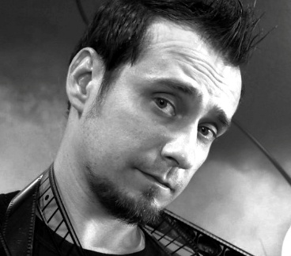

Burnaby, BC Canada

[sylvainblais21@hotmail.com](mailto:sylvainblais21@hotmail.com)

 778-233-7521

**____________________**

**Skills**

Cinematography

Staging / Blocking

Video Editing

Project Management Tools

Strong Communication

Storyboarding / Drawing

**____________________**

**Software**

Maya

Adobe Premiere Pro / After Effects

Avid Media Composer

DaVinci Resolve

Storyboard Pro **____________________**

**Recent Known Properties**

The Dragon Prince

Diary of a Wimpy Kid

Gen: Lock

Rick and Morty

Solar Opposites

Mega Man: Fully Charged

**____________________**

**References**

George Samilski | Supervising Director

[georgesamilski@gmail.com](mailto:georgesamilski@gmail.com)

(604) 404-4800

William Lau | Series Director

[goldenchild@hotmail.com](mailto:goldenchild@hotmail.com)

(604) 505-7984

***Sylvain Blais***

***Director***

**_____________________________________________**

**Profile**

Proficiencies in editing, technical animation, cameras and directing performances

12 years experience as an animation director

15 years experience as a film editor

3 years experience as a media technician

2024 Nominee Leo Best Direction in an Animation Series

2020 Winner Primetime Emmy Outstanding Animated Program

**_____________________________________________**

**Work Experience**

Animation Director **|** Bardel Entertainment Inc

*Jun 2019 – Dec 2023 - 4 years 4 months*

* Directed layout and animation
* Managed four teams of multimedia artists locally and abroad
* Assessed animators through projects and assignments

Co-Director **|** WildBrain (as DHX Media)

*Sep 2017 - Dec 2018 - 1 year 4 months*

* Directed previz, layout and animation
* Managed three teams of animators
* Provided script analysis for technical challenges

Animation Director **|** Icon Creative Studio

*Jan 2017 - Aug 2017 - 8 months*

* Directed layout and animation
* Managed one team of animators
* Staged and set cameras in maya

Animation Director ***|*** WildBrain (as DHX Media)

*Dec 2014 - Jan 2017 - 2 years 2 months*

* Directed and edited all stages of animation
* Managed two teams of multimedia artists
* Preformed technical animation assignments

**_____________________________________________**

**Education**

BCIT Television and Video Production 1995

Centennial High School 1993